-  Install ansible
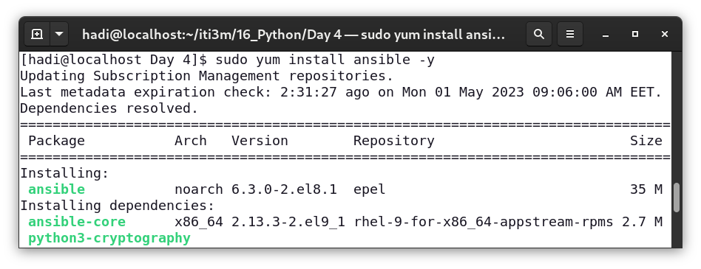
-  Create a new user on control machine and new user on host 1
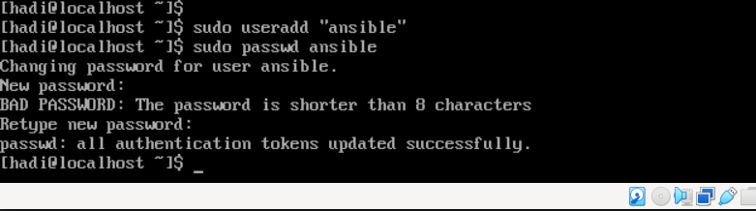
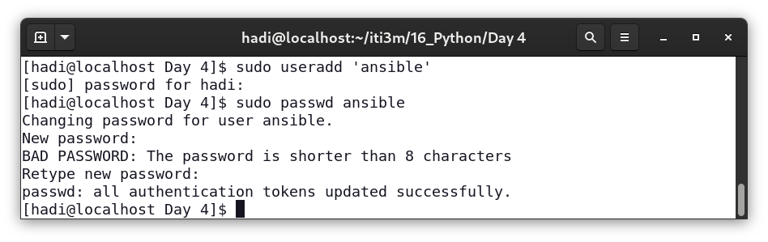
-  Make sure you can ssh into host 1 (using password)

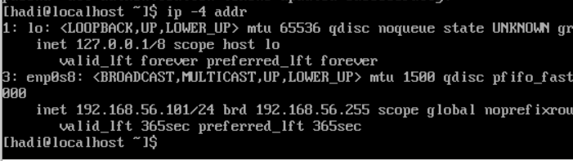
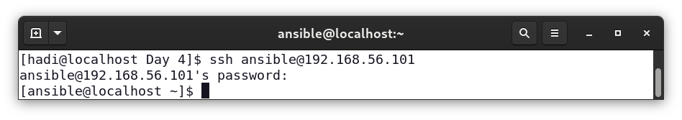
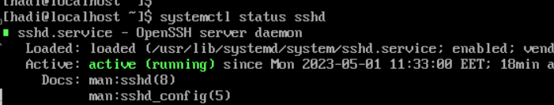
-  Generate SSH key pair on control machine

-  Copy the public key to host 1
-  Make sure you can ssh into host 1 (using prv/pub)

